Upside Down Maps.com

Upside Down Map Page
Upside Down maps (also known as South-Up or Reversed maps) offer a completely different perspective of the world we live in.
Technically speaking, even referring to the earth with words like "up" or "down" or comparing places with words "above" or "below" is flawed, considering that the earth is a spherical body (it's actually slightly "fatter" at the equator) and flying through 3 dimensional space with no reference of up or down.
However, the issue of "up" and "down" does become an issue when viewing the surface of the earth projected onto a flat piece of paper (a map). And the effect of the orientation of a map is more significant than you might realize.

History of Map Orientation
As all maps require orientation for reference, the issue of how to layout the map orientation is as old as maps themselves. As map orientation is completely arbitrary, it is not surprising that they differed throughout time periods and regions.
The convention of North-up is usually attributed to the Egyptian astronomer Ptolemy (90-168 AD). Justifications for his north-up approach vary.
In the middle ages, East was often placed at top. This is the origin of the term "The Orient" to refer to East Asia.
During the age of exploration, European cartographers again followed the north-up convention...perhaps because the North Star was their fixed reference point for navigation, or because they wanted (subconsciously or otherwise) to ensure Europe's claim at the top of the world.

Maps' Effect on World Perception
While the orientation of a map might seem harmless, it can have a significant effect on one's perception of the world, and the relative importance of the different place in it.
In speech, we often refer to places being "above" or "below" others. Think of how you would say you're about to travel to the state or country to your north or south (to go "down" to Kentucky from Indiana, or "up" to Canada from the US). Without even mentioning geography, ask any grade school student whether Mexico is "above" or "below" the United States. We're all familiar with the "land down under".
As we often correlate importance to relative height (think how a citizens of a country will fly their flag higher than all other flags), the north-up convention reinforces the idea that northern bodies are more important than their southern neighbors. Suddenly, traveling "down" to the South might have an inference much deeper than geographic location.
To summarize, unconditionally accepting the north-up map convention without at least appreciating the effect stands at odds with viewing all people and places within the world equally.
As you will see, viewing a South-up map is the perfect remedy...

Why South Up?
Here at Upside-Down-Maps.com, we do not endorse use of "upside-down" maps because this orientation is "better". Objectively speaking, there is no advantage or disadvantage to a South-up map (or East-up or West-up, for that matter). Furthermore, all of the effects to world perception described above are equally significant for any other type of orientation.
We advocate the Upside Down orientation because it is unfamiliar and thus forces us to view the world differently!
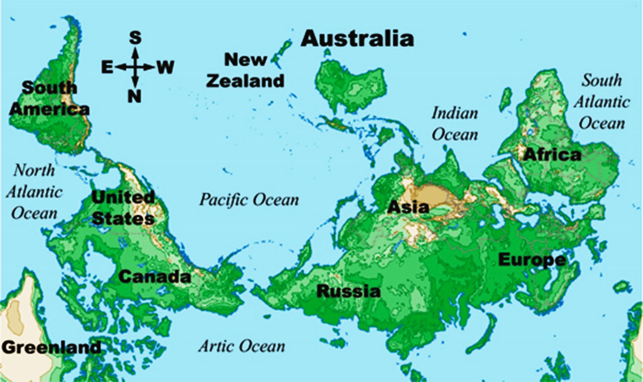
Perhaps your first impression of this reversed map is that it's wrong...Or you may immediately wonder why you haven't viewed this before...Or you may wonder what the reasoning is for North typically being at the top.
After looking at the map more closely, you may realize that the South-Up orientation may change your perception of the relative status of different places. For example, South America suddenly looks to have more prominence, and Africa and the Middle East completely dwarf Europe. Likewise, tucking Northern Europe, Canada, and Russia away at the bottom of the map, subconsciously takes away their status.
More practically, seeing the world from this upside down view point is almost like seeing the world for the first time. Geographic features of places and comparisons now can be done with a fresh perspective. When we always view something the same way, sometimes obvious features just get tuned out. It's not surprising that viewing the earth will expose geographic features that you've probably never even noticed before.
Below is a list of geographic features that we feel are much more noticeable with the South-Up orientation:
- South America is not South of North America, but in fact diagonally south EAST of North America. If you draw a line straight south (up) from the atlantic coast of Florida, you would just barely catch the western edge of South America.
- The vast majority of the land is in the Northern Hemisphere (more than 67%). This becomes very clear with the South-Up map, as all of the land seems to be bunched near the bottom of the map. Furthermore, even the southern continents of South America, Africa, and Australia are not very south at all. They all lie almost entirely within the tropics. The "southern" continent of Africa is actually mostly in the NOTHERN hemisphere.
- Russia...is still huge. The reason it might look bigger is simply that we've grown so accustomed to its size when viewing conventional maps, that we simply tune it out. Seeing the world "upside down" is almost like looking at the world for the first time, in which case the biggest country (by far) is sure to be immediately noticed.
Another aspect of maps that we find very interesting in the south-up orientation is the SHAPE of countries. Some of them just look bizarre when viewed "upside down".
